**PL/SQL for DBMS Project:**

**1: Trigger**

**When movie_id/crew_id is changed, update it in referencing tables.**

SQL> create or replace trigger tg1 after update on movie for each row

2 declare

3 old_movieid movie.movie_id%type;

4 new_movieid movie.movie_id%type;

5 begin

6 old_movieid:=:old.movie_id;

7 new_movieid:=:new.movie_id;

8 update language set movie_id=new_movieid where movie_id=old_movieid;

9 update crew set movie_id=new_movieid where movie_id=old_movieid;

10 update action set movie_id=new_movieid where movie_id=old_movieid;

11 update comedy set movie_id=new_movieid where movie_id=old_movieid;

12 update romance set movie_id=new_movieid where movie_id=old_movieid;

13 dbms_output.put_line('Successfully movie_id updated from '||:old.movie_id||'to'||:new.movie_id ||'for all the tables');

14 end;

15 /

Trigger created.

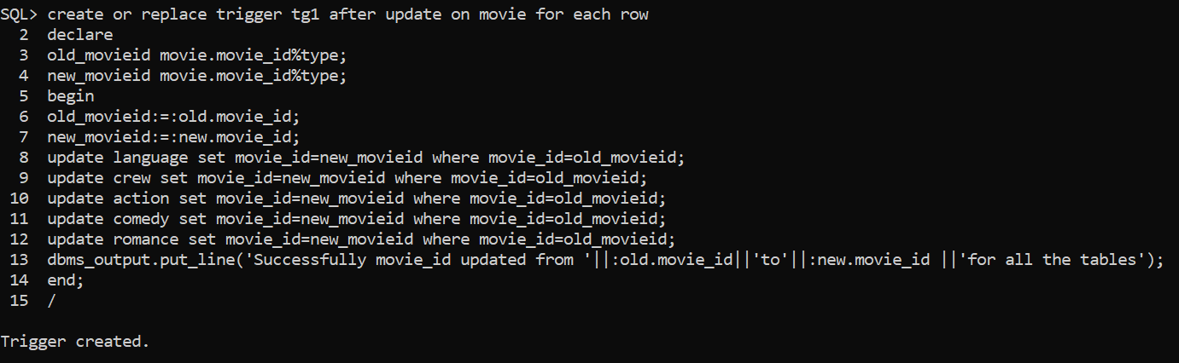

**Before activating trigger:**

SQL> select movie_id, name from movie;

MOVIE_ID NAME

---------- ------------------------------

101 Avengers_end_game

102 Extraction

103 Bahubali

104 Gully Boy

105 Morbius

106 Made_In_China

107 Entertainment

7 rows selected.

SQL> select * from language;

MOVIE_ID LANGUAGE

---------- --------------------

101 English

101 Hindi

102 English

102 Hindi

103 English

103 Hindi

104 English

104 Hindi

105 English

105 Tamil

105 Telugu

MOVIE_ID LANGUAGE

---------- --------------------

106 Hindi

107 English

107 Tamil

14 rows selected.

SQL> select movie_id,director_name from crew;

MOVIE_ID DIRECTOR_NAME

---------- ------------------------------

101 Anthony_russo

102 Sam_Hargrave

103 Rajmouli

104 Zoya_Akhtar

105 Daniel_espino

106 Anuj_Rakesh

107 Sajid

7 rows selected.

SQL> select * from action;

M_ID NAME MOVIE_ID

---------- ------------------------------ ----------

1 Avengers_end_game 101

2 Extraction 102

3 Bahubali 103

4 Morbius 105

SQL> select * from comedy;

M_ID NAME MOVIE_ID

---------- ------------------------------ ----------

1 made in china 106

2 Entertainment 107

SQL> select * from romance;

M_ID NAME MOVIE_ID

---------- ------------------------------ ----------

1 gully boy 104

2 made in china 106

**After Activating Trigger:**

SQL> update movie set movie_id=100 where movie_id=101;

Successfully movie_id updated from 101to100for all the tables

1 row updated.

SQL> select movie_id, name from movie;

MOVIE_ID NAME

---------- ------------------------------

100 Avengers_end_game

102 Extraction

103 Bahubali

104 Gully Boy

105 Morbius

106 Made_In_China

107 Entertainment

7 rows selected.

SQL> select * from language;

MOVIE_ID LANGUAGE

---------- --------------------

100 English

100 Hindi

102 English

102 Hindi

103 English

103 Hindi

104 English

104 Hindi

105 English

105 Tamil

105 Telugu

MOVIE_ID LANGUAGE

---------- --------------------

106 Hindi

107 English

107 Tamil

14 rows selected.

SQL> select movie_id,director_name from crew;

MOVIE_ID DIRECTOR_NAME

---------- ------------------------------

100 Anthony_russo

102 Sam_Hargrave

103 Rajmouli

104 Zoya_Akhtar

105 Daniel_espino

106 Anuj_Rakesh

107 Sajid

7 rows selected.

SQL> select * from action;

M_ID NAME MOVIE_ID

---------- ------------------------------ ----------

1 Avengers_end_game 100

2 Extraction 102

3 Bahubali 103

4 Morbius 105

**2: Procedure**

**Name of the movie for the given IMDB and RadioMirchi ratings.**

SQL> set serveroutput on;

SQL> Create or replace procedure p1 (IM number, RM number) is

2 cursor pas_cur is

3 select name from movie where movie_id in (select movie_id from ratings where IMDB=IM and Radio_mirchi=RM);

4 pas_rec pas_cur%rowtype;

5 begin

6 open pas_cur;

7 loop

8 fetch pas_cur into pas_rec;

9 exit when pas_cur%notfound;

10 dbms_output.put_line(pas_rec.name);

11 end loop;

12 close pas_cur;

13 end;

14 /

Procedure created.

SQL> exec p1(&imdb, &radio_mirchi);

Enter value for imdb: 7

Enter value for radio_mirchi: 7.6

Morbius

PL/SQL procedure successfully completed.

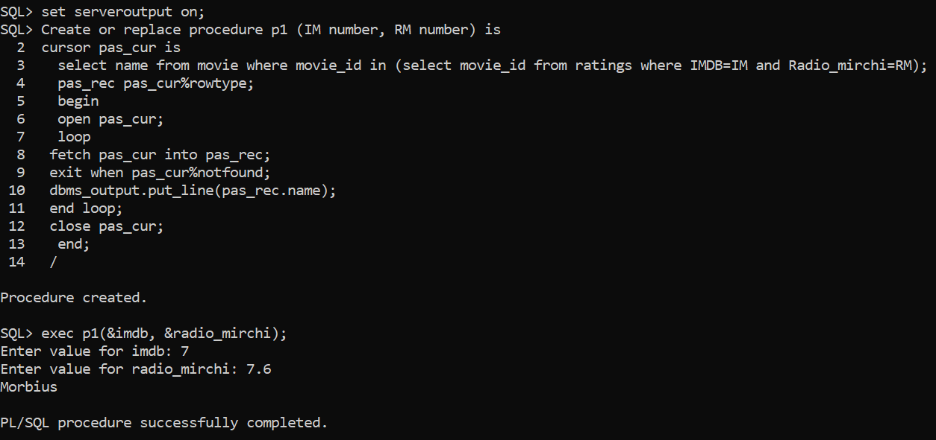

Create or replace procedure p1 (IM number, RM number) is

cursor pas_cur is

select name from movie where movie_id in (select movie_id from ratings where IMDB=IM and Radio_mirchi=RM);

pas_rec pas_cur%rowtype;

begin

open pas_cur;

loop

fetch pas_cur into pas_rec;

exit when pas_cur%notfound;

dbms_output.put_line(pas_rec.name);

end loop;

close pas_cur;

end;

/

**3: Function**

**Get the actor and return the name of the movie.**

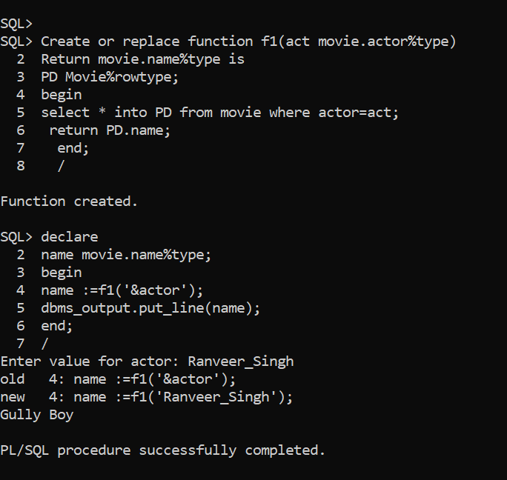

SQL> Create or replace function f1(act movie.actor%type)

2 Return movie.name%type is

3 PD Movie%rowtype;

4 begin

5 select * into PD from movie where actor=act;

6 return PD.name;

7 end;

8 /

Function created.

SQL> declare

2 name movie.name%type;

3 begin

4 name :=f1('&actor');

5 dbms_output.put_line(name);

6 end;

7 /

Enter value for actor: Ranveer_Singh

old 4: name :=f1('&actor');

new 4: name :=f1('Ranveer_Singh');

Gully Boy

PL/SQL procedure successfully completed.

Create or replace function f1(act movie.actor%type)

Return movie.name%type is

PD Movie%rowtype;

begin

select * into PD from movie where actor=act;

return PD.name;

end;

/

declare

name movie.name%type;

begin

name :=f1('&actor');

dbms_output.put_line(name);

end;

/